BIS VINNERE JULEUTSTILLING 2022

BIS VALP. Dommer: Kristine Van Rijn (NO)

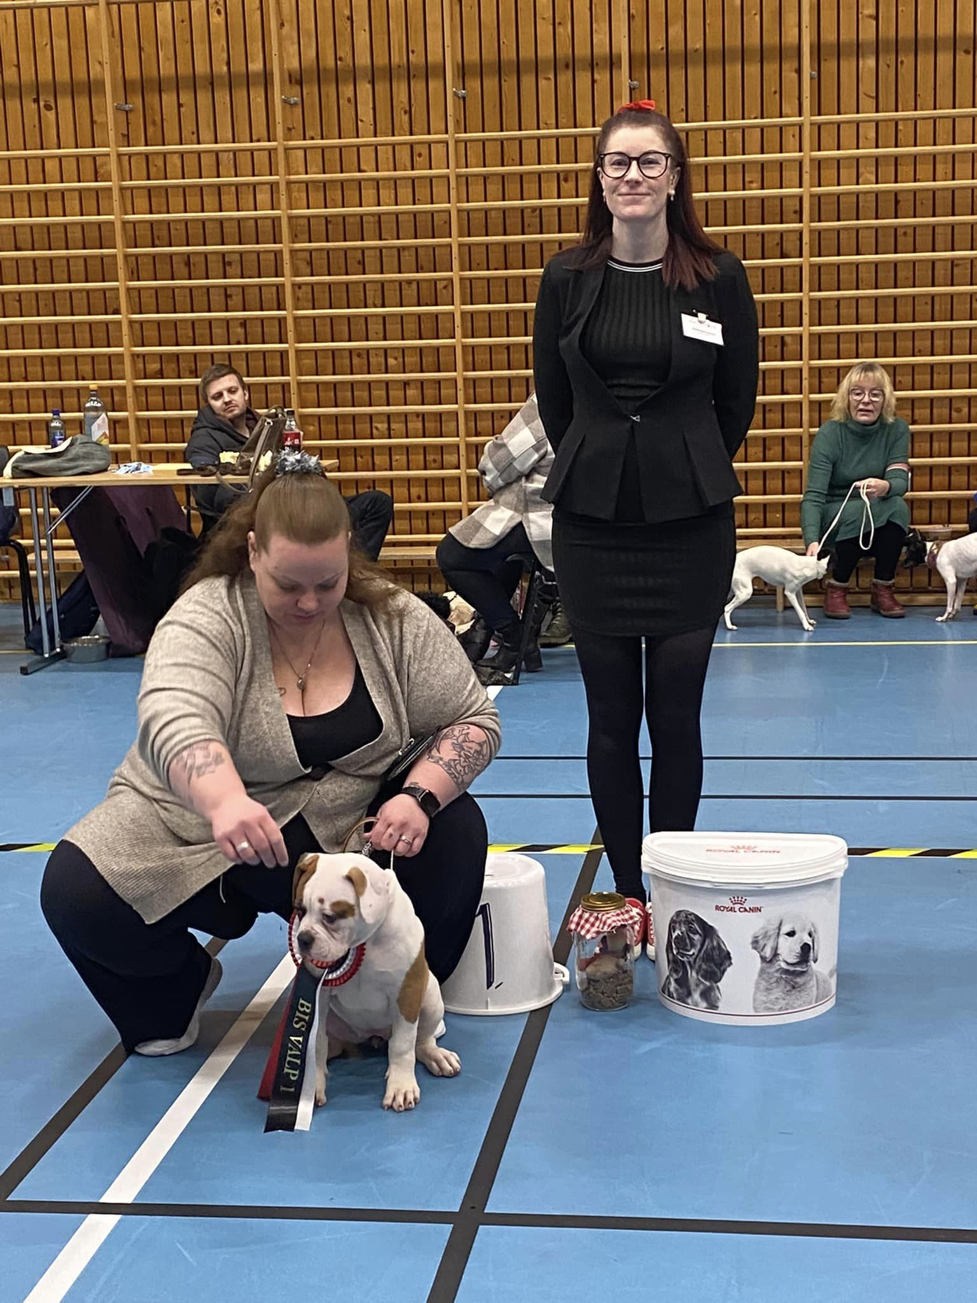

1 Blackwell’s Minnie Mouse@Soerensens AB (Amerikansk Bulldog)
2 Northern Light Alapahas Abby (Alapahas Blue Blood Bulldog)
3 Elvebyen’s Caramel (Etnahund)
4 Shameless Paws Icy As Pie (Australian Shepherd)

BIS JUNIOR. Dommer: Kristine Van Rijn (NO)
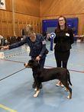

1 Dvina Av Bjerkhaug (Grosser Schweizer Sennenhund)
2 Jentestua’s Prinsesse Unike (Mellompuddel)
3 Runabjørn’s Black Magic (Shetland Sheepdog)
4 Encanto Sophie Elise (Storpuddel)

BIS UNGHUND. Dommer: Kåre Halvorsen (DK)

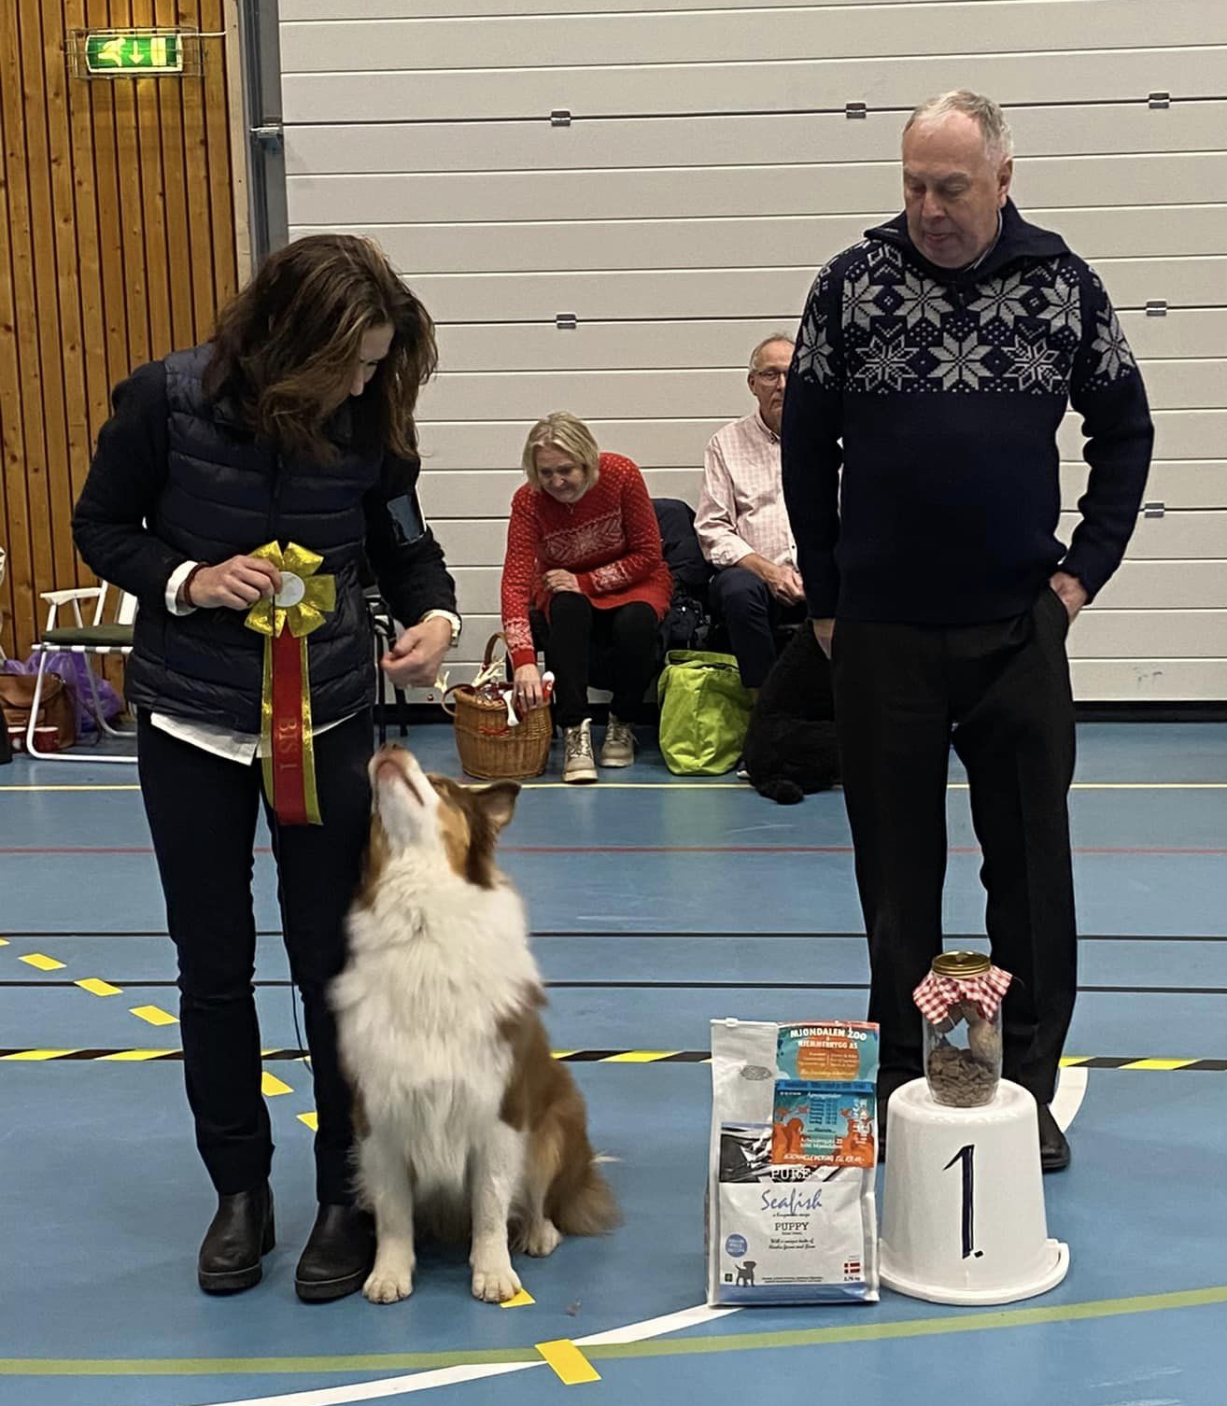
1 Shameless Paws I Know Things Now (Australian Shepherd)
2 Kathy Wildborn’s Black Lotus ( Jack Russel Terrier)
3 Eternell Love For You Wanda (Storpuddel)
4 Bikkjehaugen’s Zebastian (Newfoundlandshund)

BIS ÅPEN. Dommer: Kåre Halvorsen (DK)

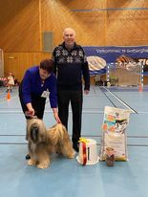
1 Ursus Sengge (Tibetansk Terrier)
2 AAA Gogo Yubari By Proxy (Amerikansk Bulldog)
3 Cayahogas Louises Belladonna (Whippet)
4 Luci WilD (Storpuddel)

BIS CHAMPION Dommer: Kåre Halvorsen (DK)

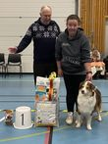
1 Coolord Melodies Calender Girl (Australian Shepherd)
2 Lahelle’s Outcast (Amerikansk Bulldog)
3 Ulfeng’s Chic Line (Storpuddel)
4 Lorita Star Neobyknovennaya Radost (Chinese Crested)

SUPER BIS VINNER JULESHOW ÅRETS HUND 2022
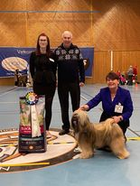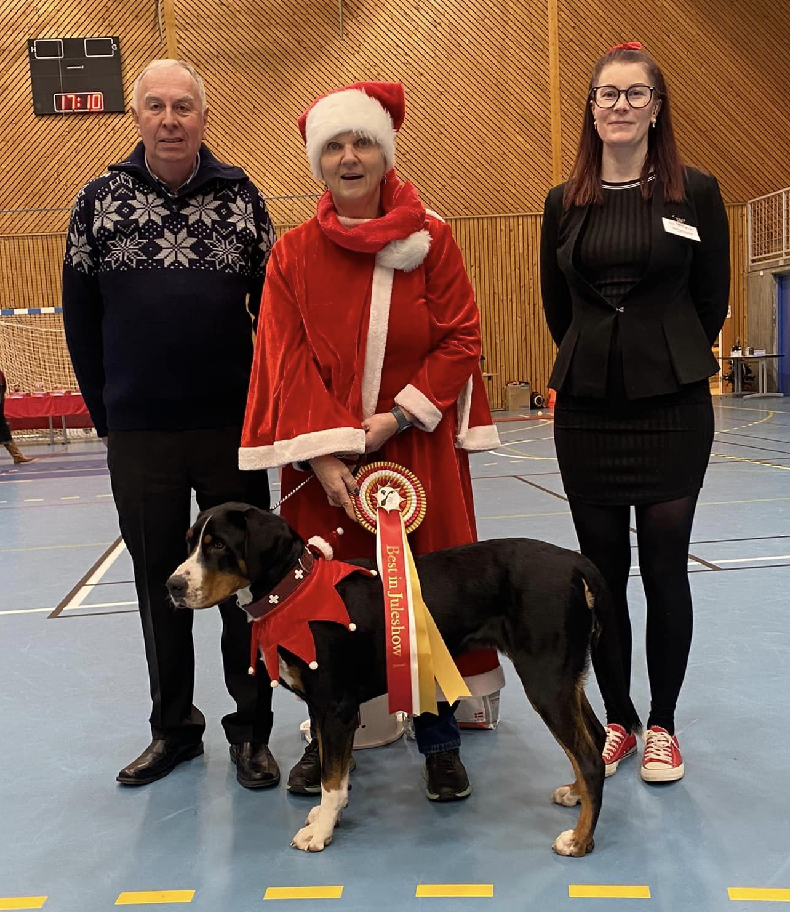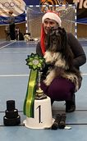
Ursus Sengge Dvina Av Bjerhaug Stella Polare’s Armani
( Tibitansk Terrier) (Grosser Schweizer Sennenhund) (Biewer Terrier)
ÅRETS HUND 2022

