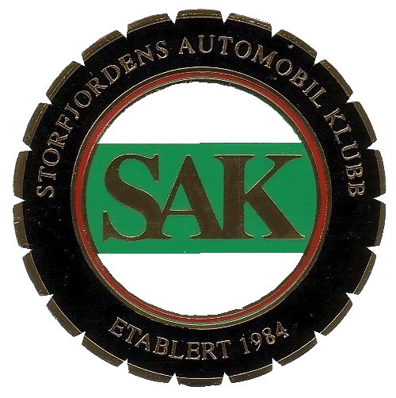
Reg.nr : _______________
Årsmodell: ______________
Bilmerke:_________________________ Modell:____________________________________
Type ¹⁾:_________________________________ 1)Sedan/Coupè/Cabriolet/Roadster/Buss/Last/Motorsykkel/Annet;skriv
Motor: HK____________ Ant cyl:____ Vol:____________
Eier: ________________________ Kommune:_______________ Mob.__________________
Første eier: ___________________________ Sted: __________________________________
Restaureringer:_________________________________________________________________
______________________________________________________________________________
______________________________________________________________________________
Historie:_______________________________________________________________________ ______________________________________________________________________________
______________________________________________________________________________
Info om biltype/modell/utrustning/tilleggsutstyr:_____________________________________
______________________________________________________________________________
______________________________________________________________________________
______________________________________________________________________________

